**ASKEW WILDLIFE MANAGEMENT AREA**



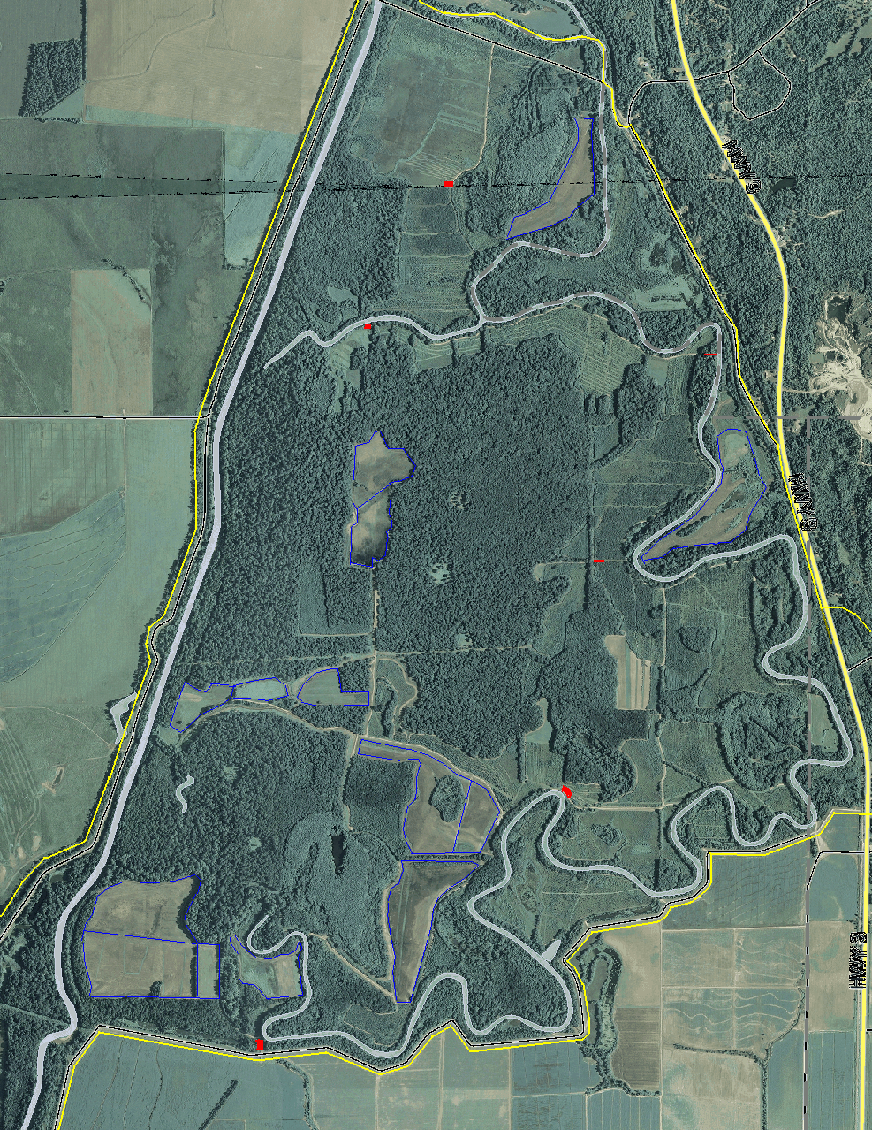

GTR #2

will be flooded

GTR #1

Will be

flooded

●

●

# S

# E

# N

# +

# W

**▬** PARKING AREAS ● Road Closed (Nov 15- Mar 15)

▬ Moist-soil Impoundments ● Main Entrance

●

DESCRIPTION OF ASKEW WILDLIFE MANAGEMENT AREA:

The Askew Wildlife Management Area consist of approximately 4300 acres of bottomland hardwood habitat. The area contains 715 acres of Greentree Reservoirs (GTR’s) and 400 acres of Moist-soil Management Areas (MSMA’s). These two areas are usually flooded and managed for wintering waterfowl and shorebirds. Management of the property is conducted by the Arkabutla Lake Field Office and the Sardis Project Management Office. For more information on the area, contact the Arkabutla Lake Field Office @ (662) 562-6261.

## ASKEW WILDLIFE MANAGEMENT

AREA 2016/2017 REGULATIONS

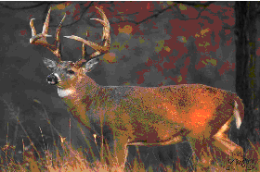

- Users must follow ALL state and federal regulations including Corps specific hunting seasons.

- The use of high-powered rifles is prohibited in this area. Shotguns and primitive weapons are allowed. The use of .22 caliber rifles is permitted for squirrel, rabbit, and raccoon hunting only.

- Deer stands must be removed after each use. Any stand found un-occupied will be removed and/or destroyed and a citation may be issued.

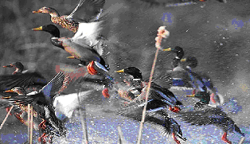- DEER/ HOG hunting with the use dogs is prohibited.

-Training of Raccoon dogs during the spring turkey season is prohibited

- Duck hunting on **Friday, Saturday,** and **Sunday** ONLY from 30 minutes before sunrise to noon.

PHOTOS COURTESY OF WEBSHOTS.COM

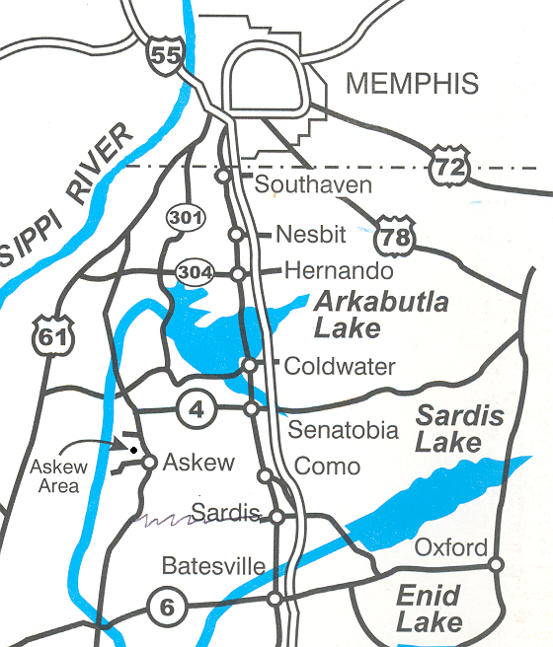- The presence or use of permanent duck blinds in the area is prohibited.

- Area closes 30 minutes after dark. Raccoon hunting and fishing are allowed after dark.

- All vehicles must stay on the roads or parking areas at ALL times. Vehicles blocking any gate or road will receive a citation.

- ATV’s are allowed **ONLY** to retrieve a harvested deer or hog. **Continued violations to this policy may result in a NO ATV policy**. Please notify us if you see any ATV’s violating this policy. Thank you.